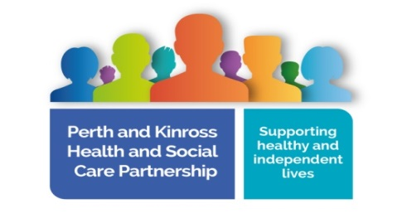

Wellbeing Team Service User Exit Questionnaire
We hope we have helped you move on with your recovery.
Please help us to evaluate and improve the service we provide by completing this form. If you would like support with this please contact your local team. We will use this feedback to make our service better.
Did we share information relevant to you about:

- Events
- Activities
- Local Groups
- Opportunities

Please circle:

Strongly agree Agree Neither agree/disagree Disagree Strongly disagree

Were we flexible enough when arranging appointments for your support?

Please circle:

Strongly agree Agree Neither agree/disagree Disagree Strongly disagree

Did you feel listened to?

Please circle:

Strongly agree Agree Neither agree/disagree Disagree Strongly disagree

Did you understand what the service was able to offer you?

Please circle:

Strongly agree Agree Neither agree/disagree Disagree Strongly disagree

Do you feel the Wellbeing Team has helped you?
Please circle:

Strongly agree Agree Neither agree/disagree Disagree Strongly disagree

What has been helpful or unhelpful?

Please share any other thoughts about our service.

If you self-referred, where did you hear about the Wellbeing Team?

If you are happy to add your name this will allow us to directly address any concerns you identify but please also feel free to leave this anonymous.
Name: ____________________________________________________________________

